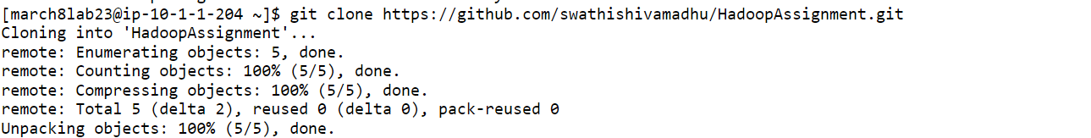

Create a folder in HDFS by name “dir01” and move input1.txt , input2.txt and input3.txt into /dir01

List only the file names present in “/dir01”

Change the replication factor for the content present in directory “/dir01” to 5 and display the replication factor for the files present in “/dir01”.
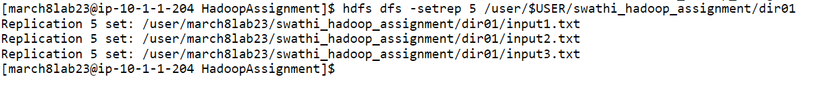

Create a folder in HDFS by name “scenario01” and create directory “level01” inside “scenario01” directory and create another directory “level02” inside directory “level01”. Once the required directories are created copy input1.txt to scenario01, input2.txt to level01 and input3.txt to level02 and finally recursively print only the file names present in directory scenario01.

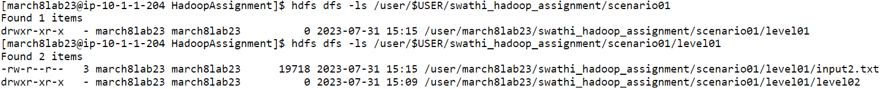

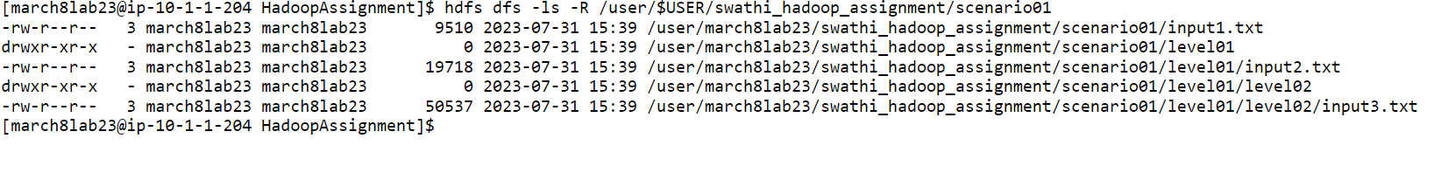

**************************************************************************
Problem Statement 02 :
Working with YARN Commands Commands
- Run MapReduce Program and capture the application Id of the job.

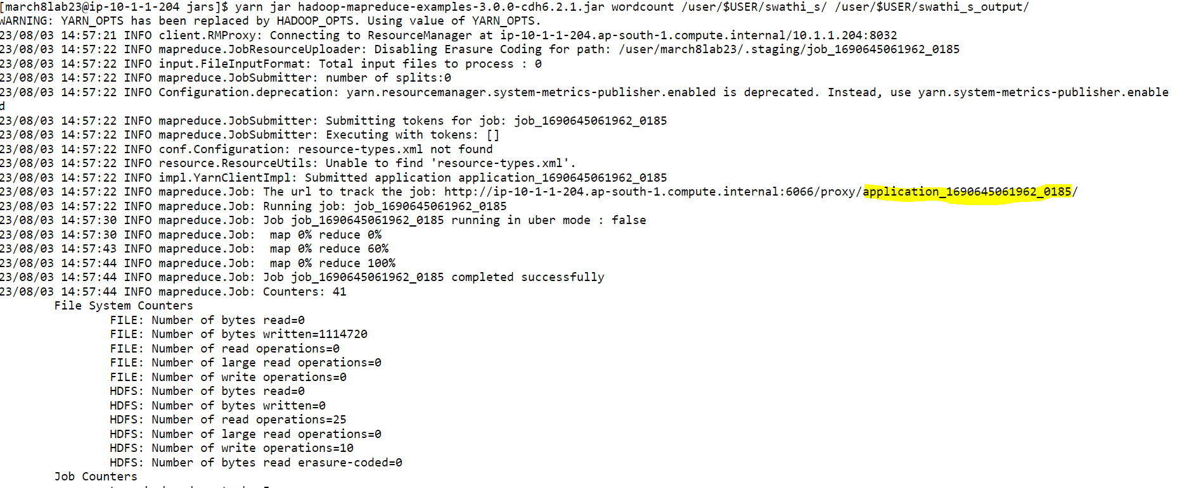

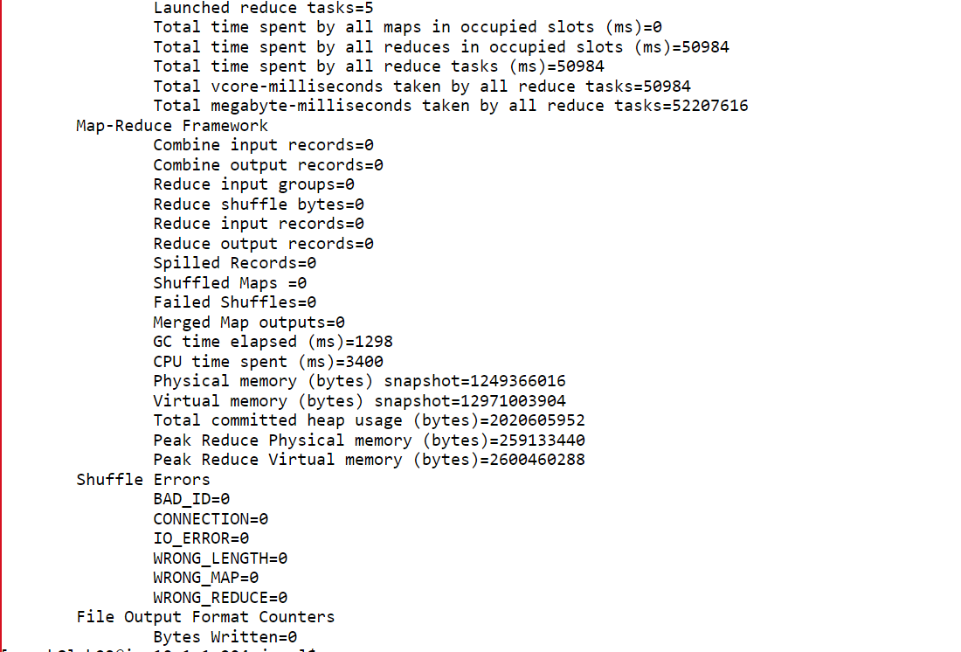

Re-run the MapReduce program and kill the application using the yarn command.

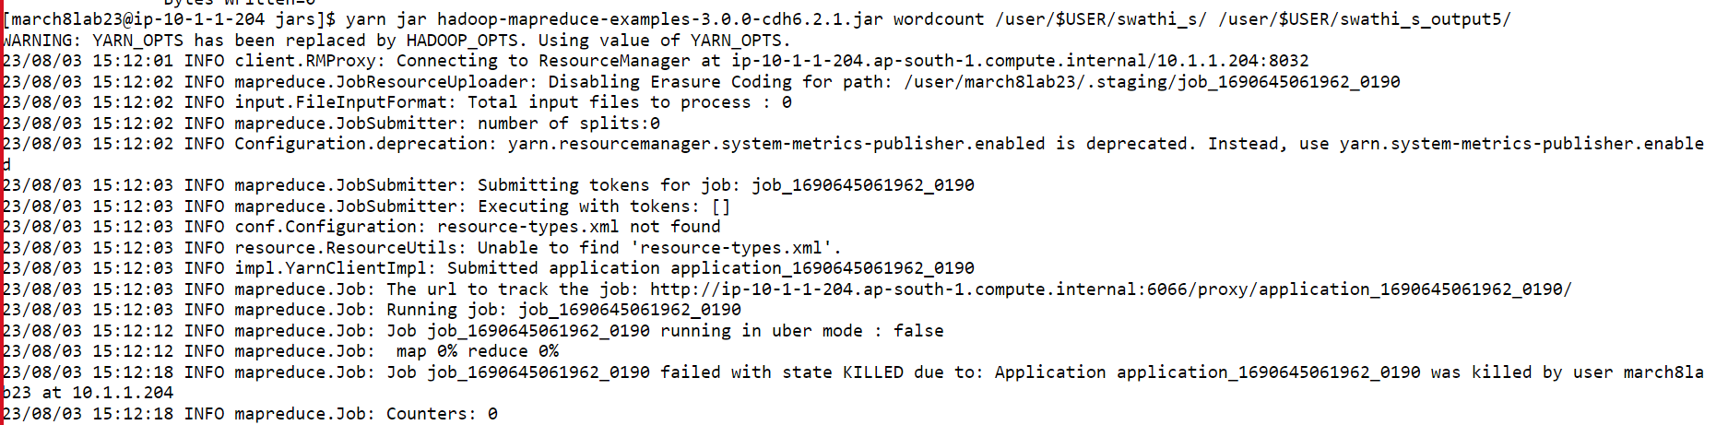

List all the applications which are RUNNING state

View the logs of any of the jobs which are already completed.

